Widgets in Tkinter:

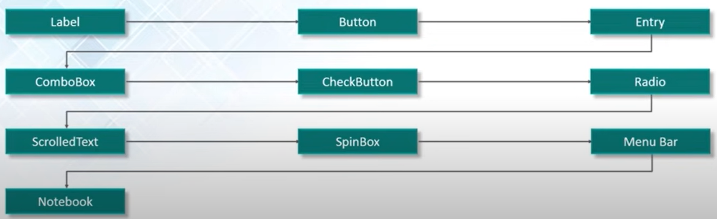

1. Label: Simple text display. “text” attribute is used to give value
   1. How to change text in label dynamically: in command definition of function do label_name.configure(text = “newtext”) OR use “textvariable” attribute that has “set()” method
   2. We can add an image in the label:

Syntax: img_var = PhotoImage(file = “D:/path_to_photo/photo.jpg”)

Label = Label(window, image=img_var)

1. Button: Like label.
   1. Has fg, bg attributes for giving color
   2. Can be given onclick event, just define a function, and enter name of that function for the attribute “command”
2. Entry: Input fields
   1. How to use value from this input field into a function: Entry_var_name.get()
3. Combo box: Top down menu
   1. 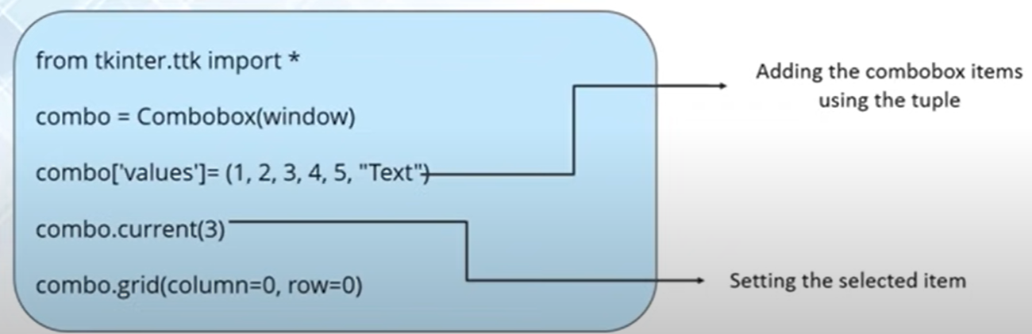
   2. We can give numeric as well as string values to the array of dropdown
4. CheckButton:
   1. 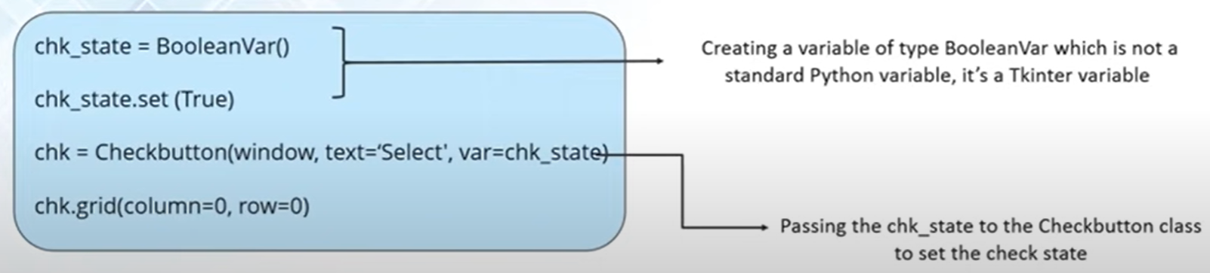
5. Radio Button
   1. 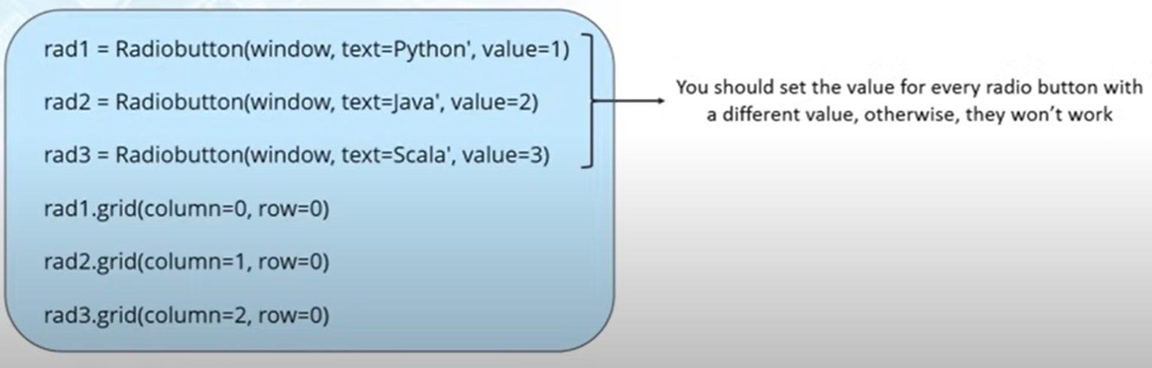
   2. Give value attribute different values
6. Scrollable text area
7. Message Box
   1. 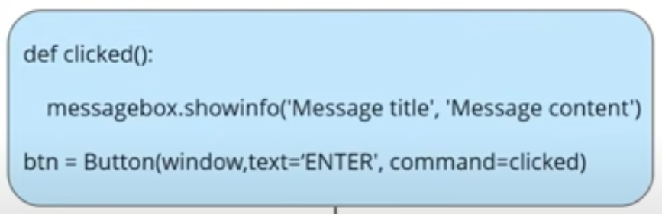
   2. New window is opened
8. Spin Box: Get a value from specified range
   1. 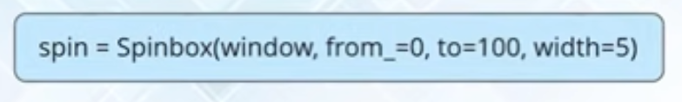

Geometry Management:

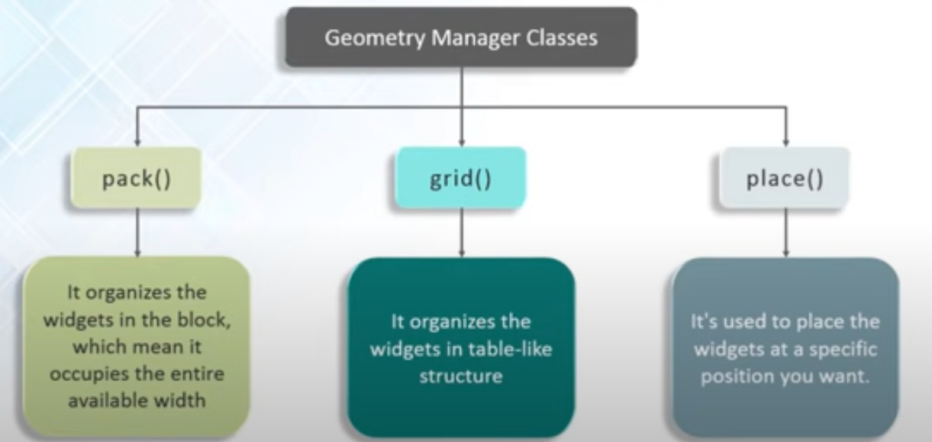

We can also use frames to divide the GUI in different logical units.

Event Handling:

Bind(): it is a function that can be called on any widget: widget_name.bind(“<Button-1/2/3>”, function_name). This function keeps on calling the specified.